2. Reverse a string using recursion, input string is “This is the problem to practice”.

**PROGRAM:**

class ReverseString

{

void reverse(String str)

{

if ((str==null)||(str.length() <= 1))

System.out.println(str);

else

{

System.out.print(str.charAt(str.length()-1));

reverse(str.substring(0,str.length()-1));

}

}

public static void main(String[] args)

{

String str = "This is the problem to practice";

ReverseString obj = new ReverseString();

obj.reverse(str);

}

}

**OUTPUT:**

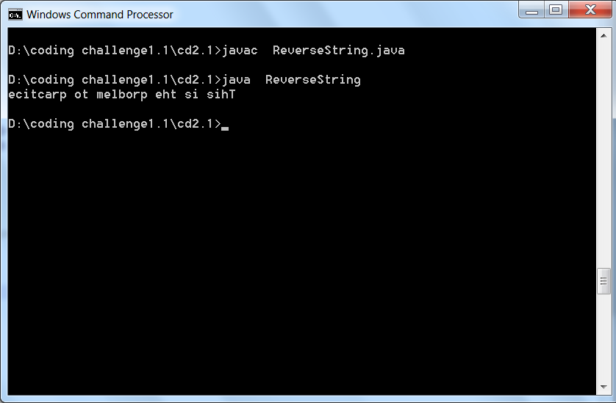

3. Reverse position of words in a string using recursion, input string is “This is sample text” the output should be “text sample is This”

**PROGRAM:**

public class ReverseWords

{

public static void main(String[] args)

{

String s[] = "This is sample text".

split(" ");

String ans = "";

for (int i = s.length - 1; i >= 0; i--)

{

ans += s[i] + " ";

}

System.out.println("Reversed String:");

System.out.println(ans.substring(0,

ans.length() - 1));

}

}

**OUTPUT:**

